附件一：摘要模板（中英文均接受）

The impact of perceptual load on unconscious emotional processing

Lili Wang, Chunliang Feng, Yuejia Luo*

Institute of Affective and Social Neuroscience, College of Psychology and Sociology, Shenzhen University, Shenzhen China, 816050 (luoyj@szu.edu.cn)

Objective
Emotion stimuli can be processed without conscious awareness. Recent studies have shown that the processing of invisible stimuli can be modulated by perceptual load. However, it is unclear whether the processing of unaware fear can be influenced by perceptual load. Because fearful stimuli are important to human survival, the unconscious processing of fearful stimuli may be independent of perceptual load. Here, we used event-related potentials (ERPs) to assess whether perceptual load has an influence upon unconscious emotional processing.

Methods
16right-handed students were recruited as paid volunteers from a university. Faces were black and white photographs taken from native Chinese Facial Affective Picture System. Target face stimuli consisted of 20 fearful faces and 20 neutral faces. The perceptual load was manipulated for a letter search task presented at fixation, and facial expressions (fearful or neutral) were presented peripherally (16.7 ms) and masked such that conscious awareness was prevented. The letter string comprised one target letter (N or X) and five non-target letters (H, K, M, W, or Z) arranged in random order. Low load letter strings were made of 6 Xs or 6 Ns, whereas high load strings consisted of one of the target letters and the five non-target letters in random order (e.g. ‘NHKWZM’). Participants were instructed to discriminate the target letters at fixation or the facial expression in the periphery.

Results & Discussion
Participants were faster and committed fewer errors in the low load condition than in high load condition. Peak amplitude of N170 was measured at occipital-temporal sites (PO7 and PO8) as the maximal negative peak in the time window 150-190 ms. Fearful faces elicited larger N170 amplitudes than neutral faces over the right hemisphere in both face task and low load condition, but the N170 effect was eliminated under high load condition, suggesting that the processing of unconscious fear depends on perceptual load.

Conclusions
The N170 effect was eliminated under high load condition, suggesting that attention resources are needed for the processing of non-conscious emotional stimuli. Our study provides initial

evidence that perceptual load may affect the mechanisms underlying unconscious fearful processing.

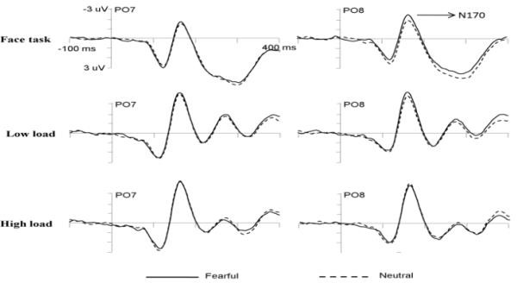
Acknowledgement: This work was supported by the NSFC (30930031).
Figure 1.Grand average ERP waveforms elicited by masked fearful faces and masked neutral faces in the face task and in the letter task with low or high perceptual load at

